**How To Backup and Restore The DataBase in MS SQL Server Management Studio**

* First Backup the database from ms sql server
* Open the ms sql server and select the database and Right click on the database select the task and we have the option like Restore,Backup and select the Backup option it will open it.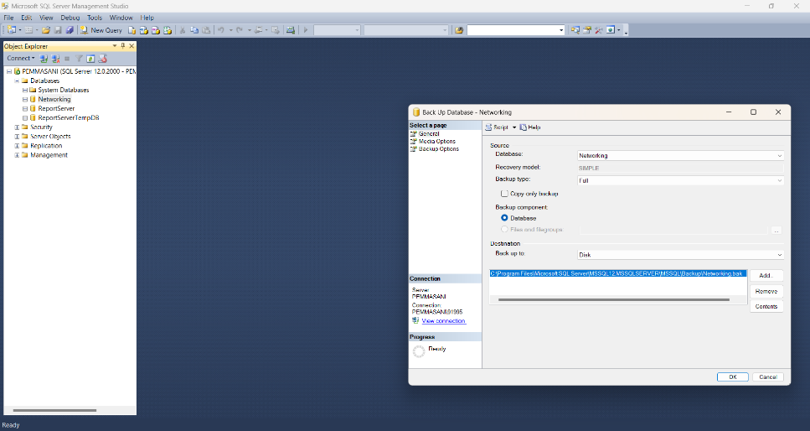
* **In above process select the databse in source and the backup type there two option one is Full and Differential .Full means it select the full backup of the database and another one is Differential means it select the only update backup only.**
* **After that select the destination where we store the backup c:\folderpath and it.**

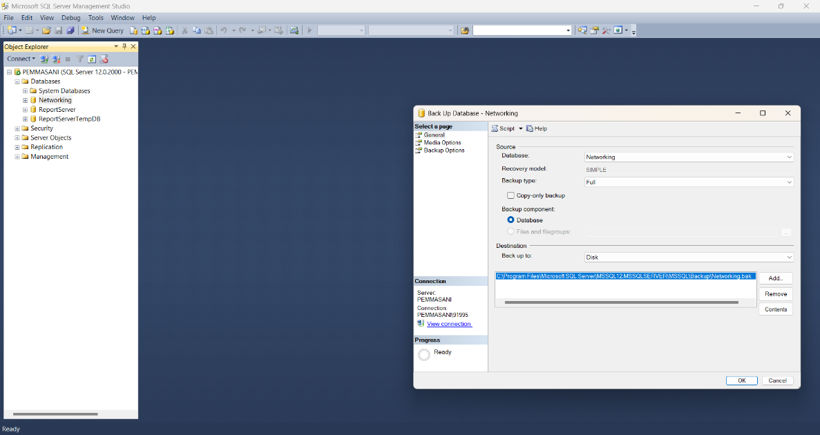

* **Click on OK it will show the it will show the file name must be in .bak and click ok.**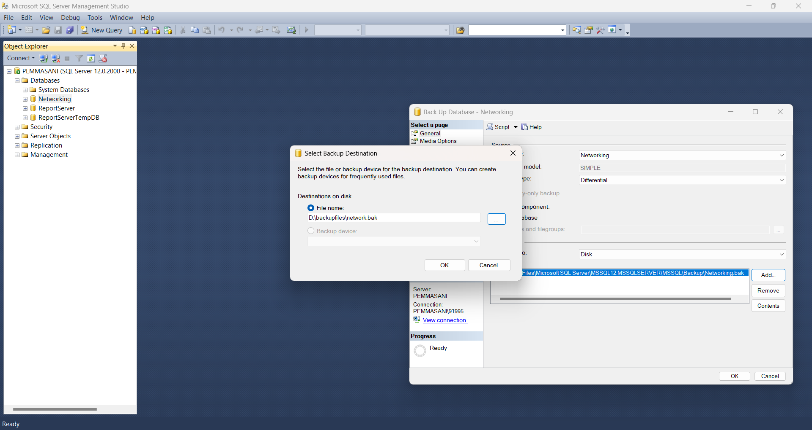

**Restore the database from windows to ms sql server Management studio**

* **Open the ms sql studio and connect to it.**
* **After that select the database it show some options like task and other option and you select the task and click on the restore option.**

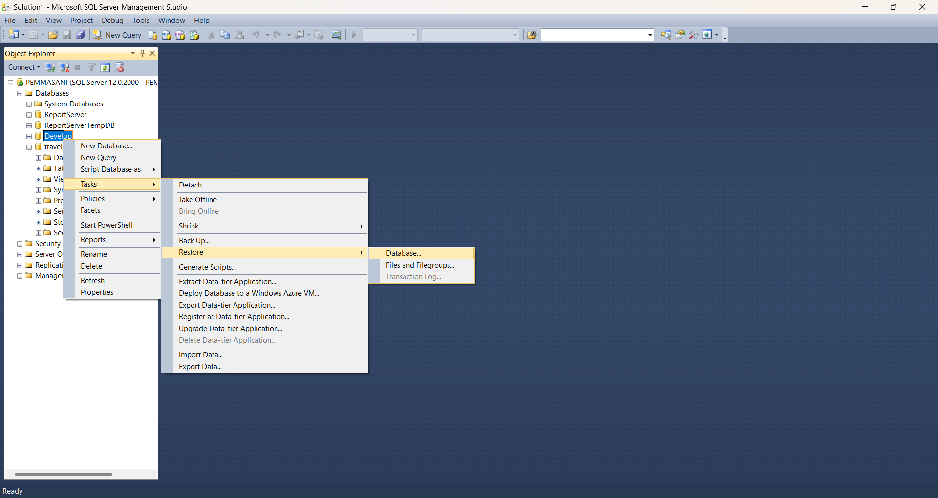

* **Ater that it will open the screen like this**
* 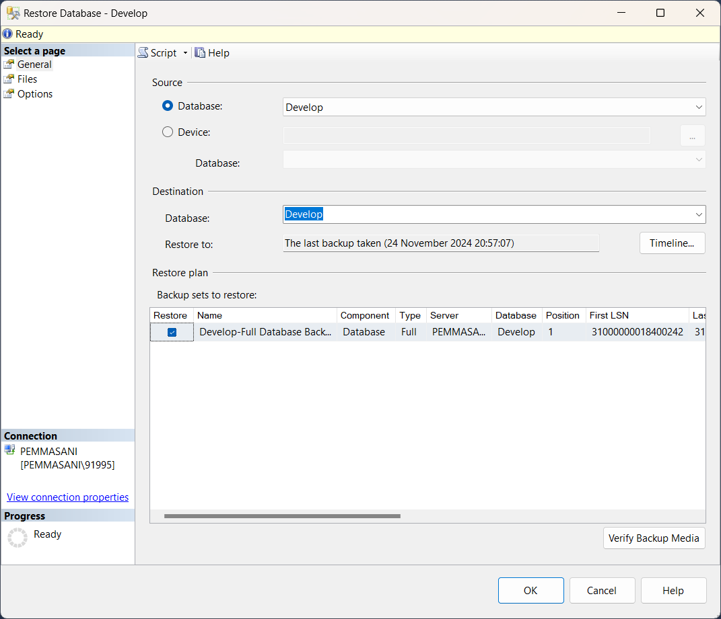
* **You select the device and it select backup file from the folder after that select the Destination field**

**Write the database it like ‘s new database and click on the back file was stored in new database.**